**Project Report**

**Fundamentals of Thermal Science**

**Solar Heat Transfer and Water Circulating Machine**

Hammad Khan 9978  
Mechatronics Department  
P.A.F K.I.E.T UniversityKarachi, Pakistan  
hammad.khan3019@gmail.com

***Abstract---* To transfer the maximum Heat from Solar Radiation and store it in storage tank for later uses.**

1. **INTRODUCTION**

**Solar Heat Transfer Machine is a physical device used to transfer solar radiation into generated heat by the heat transfer process of conduction and convection.**

The machine uses iron plate and brass/copper pipes to transfer heat to water through conduction and convection, while heat is produced by the natural source Sun.

1. **APPARATUS**

* Solar Heater
* Induction/resistance Heater
* Centrifugal motor pump
* Arduino/PIC18 controller
* Display 16x2,Keypad
* Electrical components(Passive and Active)
* Sensors(electrical thermometer, thermistors LM35 NTC and PTC
* Temperature counter, Motor controlling circuit, induction controlling circuit, valve controlling circuit, water storing and Re-Heating mechanism

1. **WORKING PRINCIPLE AND WORKING OF MACHINE:**

The mechanism uses 3 modes of heat transfer: Radiation, Conduction and Convection respectively.

Our objective is to make use of free and abundant Solar heat to maximum capacity. Therefore, our target is to use, channelize, store and reuse this solar heated water as much as possible. We are trying to accomplish this by use of 3 heat transferring processes: Radiation, Conduction and Convection respectively.

**Radiation is emission/transmission of energy in the form of waves which does not require a medium to pass through (exception nuclear radiation etc.).**

**Conduction is the process by which heat energy is transmitted through collisions/vibrations of particles themselves in one/more than one media.**

**Convection is the process by which heat is transferred by actual movement of particles from one medium to another, and it happens on the interface of two mediums.**

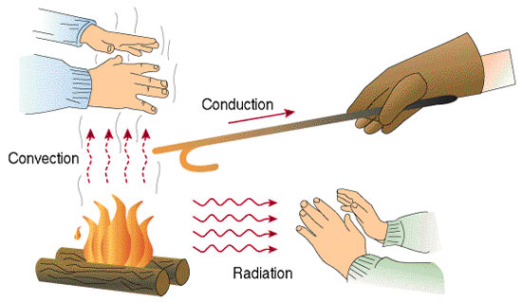

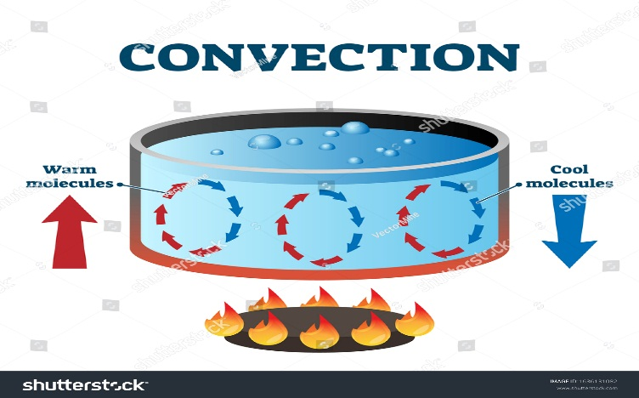

Our machine utilizes the abundant Solar Heat from the Sun, and uses it to Heat up the water. This abundant solar radiation depends on following factors namely **Temperature of the surface and Nature of the surface, other factors include Angle of exposure, Activation energy and type/color of material used**. The formula used to calculate Radiation Heat Transfer is $Qnet=σeA({T2}^{4}-{T1}^{4})$

The angle of the Solar Plate is set such that it absorbs max radiation, the plate used is of thin Iron plate, black in color, for maximum absorption.

After this the Iron plate conducts this Solar Heat Radiation to the whole of plate by the principle of conduction, $q=-k∇T$, factors including **temperature gradient, cross-section of the material, length of the travel path, and physical material properties**. The temperature gradient is the physical quantity that describes the direction and rate of heat travel.

For maximum conduction we have used Iron Plate and within that plate we have used Sand, which is known to have good conduction property due to low heat capacity. Also the granular nature of natural sand increases conduction to every smallest area possible.

Once metallic plate starts heating up by conduction, we let it heat the water flowing inside the metallic plate going through brass/copper pipes. Brass and copper are known to have best conduction properties hence they will aid greatly in the process of convection, heating up the water flowing inside.

The formula of convection heat transfer rate is $q=hA∇T$ and the factors on which convection depends on are: **Heating and cooling of fluid, changes in fluid density and force of gravity**. Other Strong Factors are **the fluid properties and roughness of the solid surface, and the type of the fluid flow (laminar or turbulent)**.

We used water because water is known to have a very high heat capacity therefore, it can transfer heat conducted through pipes to storage tank very efficiently and will therefore store the absorbed heat to a much longer period of time.

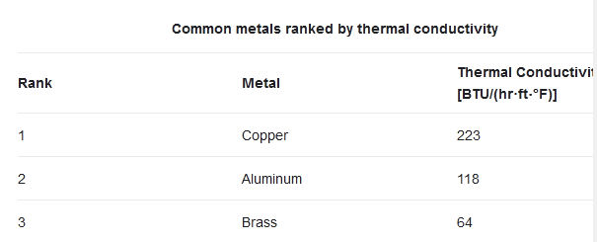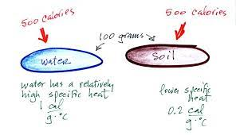

1. **INNOVATION AND IMPROVEMENT**

The innovation and improved that can be made so that the transfer rate of heat from Solar radiation to water can be maximized is to use a Microcontroller Feedback System which will observe temperature changes and environment and adjust the speed of motor to circulate the water after absorbing maximum heat.

Another improvement is to use Induction Heater which will heat the water if the required temperature is far greater than what can be supplied by our heater but here we have a good initial temperature to start around 30-50ºC.

The another most significant improvement made is the use of Convex Lenses or Concave Mirrors which will direct solar radiation to specific points of pipes and hence maximize the radiation transfer/absorption to metallic pipes.

